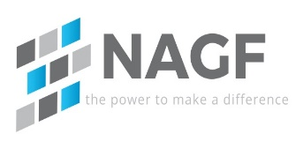

Hello!

Thanks for your interest in the North American Generator Forum. I am here to help guide you through the application process. Attached is a consultant membership application, and some background material. Please fill out the application, have it signed by your sponsor (existing NAGF member) and return it to me and Wayne Sipperly (wsipperly@generatorforum.org). Upon approval, I will grant you access to our collaboration site, hosted by Groupsite, and send you a Groupsite tutorial to help get you started.

If you have any questions, feel free to contact me via phone or email.

Best Regards,

Heather Morgan
NAGF Secretary
Heather.morgan@edpr.com

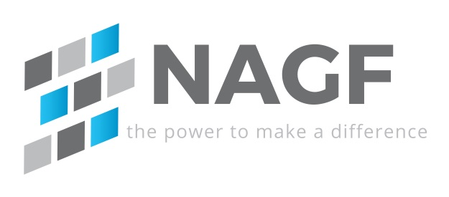

APPLICATION FOR CONSULTANT MEMBERSHIP
- Parties. This agreement is between the North American Generation Forum, Inc., and Consultant Applicant Name (“Consultant Applicant”).
- Consultant Applicant. The Consultant Applicant includes the parent company and all associated subsidiaries for which the parent company desires to include under their membership. The Consultant Applicants is not permitted to vote on Forum policies.
- Eligibility. The Consultant Applicant must be sponsored by a current Forum member by whom the Consultant Applicant is actively employed. Consultant Applicants may not sponsor other Consultant Applicants. The eligibility of the Consultant Applicant will be reviewed at least annually.
- Primary Representative. The Consultant Applicant represents that the signatory to this application will be the Consultant Applicant’s Primary Representative to the Forum, who has full authority to execute and deliver this Application for Membership on behalf of the Consultant Applicant.
- Forum Policies. The Consultant Applicant acknowledges receipt and review of the Forum Policies, and agrees to abide by current and future policies (as voted and approved by the Forum members) as a condition of participation in Forum activities. The Consultant Applicant further acknowledges and agrees that the condition of participation in Forum activities upon acceptance of the Forum Policies is reasonable and appropriate for the conduct of the Forum’s activities and the accomplishment of its purposes.
- Termination of Membership.
  - By the Forum. The Forum can terminate the Consultant Applicant’s membership in accordance with the Forum’s Policies in effect.
By the Consultant Applicant. The Consultant Applicant may terminate its membership at any time.

Primary Representative: |  | Primary Representative |  |  | Title: | Title
 |  |  |  |  | Date: | Date
Address 1: | Address
Address 2: | Address
City: | City |  | State or Province: | State or Province |  | Zip or Postal Code: | Zip or Postal Code
Telephone: | Telephone |  | E-mail: | E-mail

Alternate Representative: |  | Alternate Representative |  |  | Title: | Title
Address 1: | Address
Address 2: | Address
City: | City |  | State or Province: | State or Province |  | Zip or Postal Code: | Zip or Postal Code
Telephone: | Telephone |  | E-mail: | E-mail

Membership Contact: |  | Alternate Representative |  |  | Title: | Title
Address 1: | Address
Address 2: | Address
City: | City |  | State or Province: | State or Province |  | Zip or Postal Code: | Zip or Postal Code
Telephone: | Telephone |  | E-mail: | E-mail

Sponsor Contact: |  | Alternate Representative |  |  | Title: | Title
Company: | Address
Address 1: | Address
Address 2: | Address
City: | City |  | State or Province: | State or Province |  | Zip or Postal Code: | Zip or Postal Code
Telephone: | Telephone |  | E-mail: | E-mail

